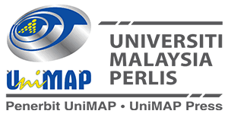

TEMPLATE PENYEDIAAN BAB DALAM BUKU
[CONTOH HALAMAN PRELIM/AWALAN UNTUK MANUSKRIP]

KANDUNGAN/CONTENTS

TEMPLATE PENYEDIAAN MANUSKRIP

[CONTOH HALAMAN BAHAGIAN ISI KANDUNGAN]

[CONTOH HALAMAN BAHAGIAN TEKS]
[Saiz Rupa Taip 12 point dan jenis taip Times News Roman/Arial]

1
[Saiz Rupa Taip 12 point]

SURFACE TREATED RECYCLED CONCRETE AGGREGATE (RCA) AS GREEN CONSTRUCTION MATERIAL

[Saiz Rupa Taip 14 point]

Aiman Alodain, Ahmad Ruslan Mohd Ridzuan, Mohd Afiq Mohd Fauzi, Nor Hayati Abdul Hamid and Mohd Shafee Harun

[Saiz Rupa Taip 10 point]

  - INTRODUCTION [saiz 12pt, UPPERCASE, bold]

Concrete has never been claimed as an environmentally friendly material because of its damaging nature resource consumption and severe environmental impact after used. Nevertheless, it will remain one of the major construction materials being utilized worldwide for the construction of infrastructures, houses and commercial buildings. By taking the concept of sustainable development into consideration, the concrete industry has to be implemented at various strategies with regards to future used of concrete, for instance the recycle used of aggregate. In general, aggregates occupy about 55% to 80% of concrete volume of the constructed buildings. Without any proper alternative of aggregates being utilized for the year future, the concrete industry globally will consume about 8 to 12 billion tons annually of natural aggregates after the year 2010 (Tu et al., 2006). The large consumption of natural aggregates from the quarry will affect the environment and reduce the natural resources.

1.1.1 Properties of RCA Concrete [saiz 12pt, Capitalize Each Word, bold]

1.1.1.1 Workability of RCA Concrete [saiz 12pt, Capitalize Each Word, bold, italic]

1.1.1.1.1 Compressive Strength of RCA Concrete [saiz 12pt, Capitalize Each Word, italic]

[Bagi penggunaan sistem penomboran di atas digalakkan dalam bidang sains kejuruteraan, walau bagaimanapun, penggunaan sistem penomboran bergantung kepada kesesuaian manuskrip yang dihantar]

Contoh Penggunaan Rajah (Figure):

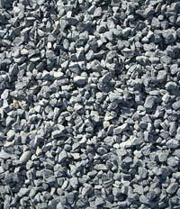 | 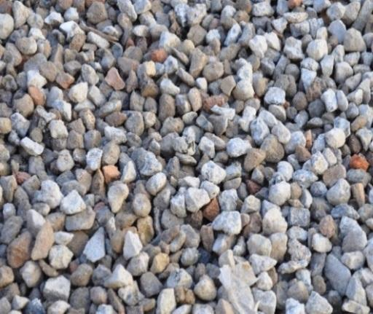 | 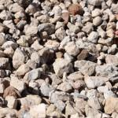
Figure 1.1. Three different types of recycle aggregates obtained from sites.

[Saiz Rupa Taip 11 point]

Contoh Penggunaan Jadual (Table):

Table 1.1 Properties of the coarse aggregate (Thomas et al. 2013)

[Saiz Rupa Taip 11 point]

Property | Aggregate
Property | NA (6/12) | NA (12/20) | RCA (6/20)
Relative density of particle (g/cm³) | 2.51 | 2.54 | 2.32
Density of particle saturated with dry surface (g/cm³) | 2.55 | 2.59 | 2.31
Water absorption (wt. %) | 1.8 | 1.6 | 5.3

[CONTOH RUJUKAN/REFERENCES]
[Rujukan diletakkan pada setiap akhir bab]

RUJUKAN/REFERENCES
(Perlu ada)

Bahagian ini mentakrifkan senarai yang disediakan oleh penulis untuk memudahkan pembaca mendapatkan bahan-bahan tambahan. Rujukan ditulis/diberikan dalam gaya APA.

Contoh:

Contoh Rujukan: BUKU
Jalil,M. et al. (2013). Semiconductor Optical Amplifiers and Related Applications. Skudai: Penerbit UTM Press.

Contoh Rujukan: JURNAL
Nakamura S. and K. Tajima. 1997. “Experimental Investigations on High Speed Switching Characteristics of a Novel.” Applied Physics Letter, 65 (1): 283-455.

Contoh Rujukan: PROSIDING/CONFERENCE
Mecha, B. et al. 1998. Nonlinear Responds of a Spar in Deep Water”. Proceeding of the fifth International Offshore and Engineering Conference. The Netherlands, 11-15 June.

Contoh Rujukan: TESIS
King, K. 1987. “Development of Pressurised Systems for Oxidation Studies”. Unpublished ph.D. Thesis. Pennsylvania University.

Contoh Rujukan: LAMAN SESAWANG/WEBSITE
Global Security.org. 2016. “Tension Leg Platform technology”. Retrieved from http://www.globalsecurity.org/military/systems/ship/platform (accessed on 4 november 2017.

Bilangan halaman bagi setiap bab mestilah seimbang antara bab-bab yang lain dan sekurang-kurangnya 15-30 halaman.

[CONTOH HALAMAN AKHIRAN UNTUK MANUSKRIP]

BIODATA PENULIS
(Jika ada)

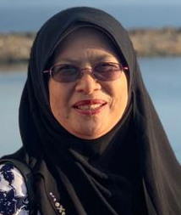 | Prof Dr Nor Hayati Abdul Hamid has been working as a lecturer at University Teknologi Mara, Shah Alam, Selangor for 26 years. She completed her PhD (Earthquake Engineering) from University of Canterbury, Christchurch, New Zealand in 2006. She received her Master of Science in Construction Management and Structural Engineering from University of NewCastle Upon Tyne, United Kingdom in 1993 and obtained her BSc (Civil Engineering) from University of Pittsburgh, United States of America in 1989. Her research interests’ fields are based-isolation system, seismic performance of precast buildings and tunnel form building under earthquake excitation, seismic performance of beam-column joints with corbel designed using BS8110 and Eurocode 8. She had published more than 200 articles in journals and conferences.
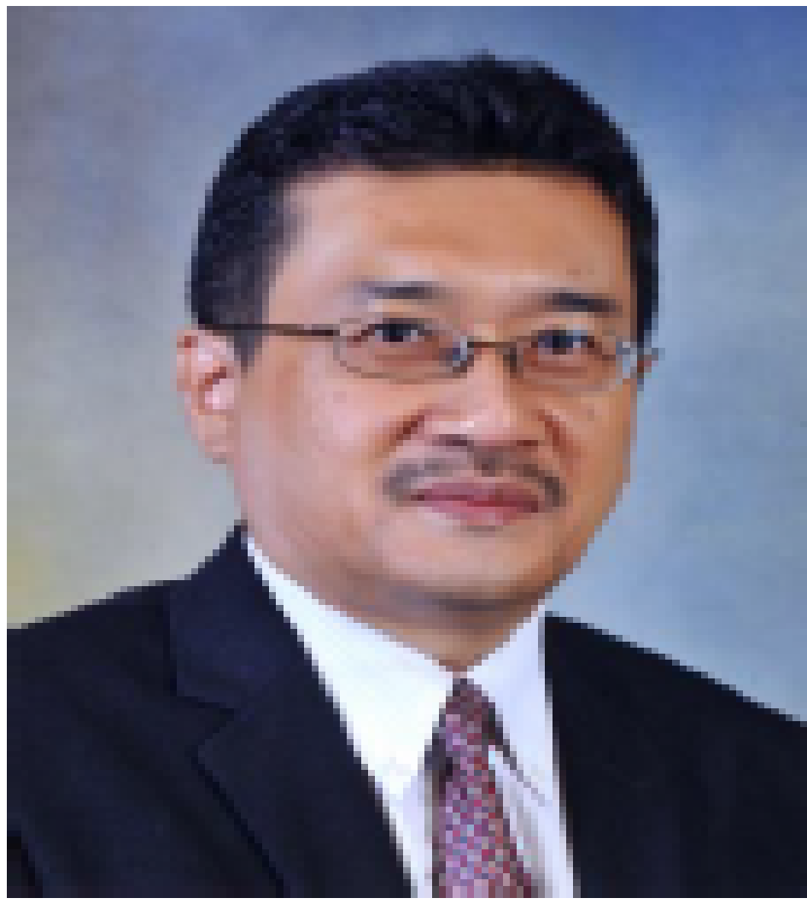 | Assoc. Prof. Ir. Dr. Ahmad Kamil Arshad graduated PhD from Universiti Teknologi Mara, Shah Alam, MSc in Highway & Transportation from Universiti Putra Malaysia and BSc from Curtin University of Technology, Perth, Western Australia. He has about 20 years’ experience in the civil engineering industry with various organizations in Malaysia. His area of interest is the management, planning and design of highway systems, particularly in pavement engineering. His research focused on environmental-friendly and sustainable asphalt materials, pavement design and rehabilitation, sustainable transportation and traffic engineering. He is a Professional Engineer registered with the Board of Engineers and the Corporate Member of The Road Engineering Association of Malaysia and a Fellow of The Institution of Engineers, Malaysia (FIEM).

